**Practical 6**

**Aim:** To implement Nested Queries

**Q**) Create a Table Employee with the following attributes Eno, Ename ,addr, salary ,department_no

Insert 5 rows any 2 employees may have the same department_no and answer the following queries :

1. Select Ename, Eno,addr from employee where salary >( select salary from employee where Ename=’Aditya’
2. Select Ename, Eno, from employee where salary < any( select salary from employee where department_no=’9’
3. Select * from employee X where X.Salary > (select avg(salary) from employee where department_no= X.department_no

**Answers :**

**Step 1: Create the Table Employee**

CREATE TABLE EMPLOYEE(ENO NUMBER(10) PRIMARY KEY,ENAME VARCHAR(50) NOT NULL, ADDR VARCHAR(50) ,SALARY NUMBER(20), DEPT_NO VARCHAR(20) );

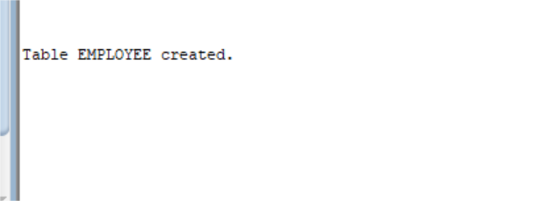

**Step2: Insert the values in the table**

INSERT INTO EMPLOYEE VALUES(123,'Deivangh','ufcueu',10000,10);

INSERT INTO EMPLOYEE VALUES(456,'Himanshu','dqjnecbgh',20000,2);

INSERT INTO EMPLOYEE VALUES(789,'Aditya','jdjahsjb',30000,5);

INSERT INTO EMPLOYEE VALUES(289,'Hitesh','jxqonoq',40000,5);

INSERT INTO EMPLOYEE VALUES(713,'Jeetika','jxkenw',50000,9);

**Step 3: Now perform the following queries**

1. SELECT ENO,ENAME,ADDR FROM EMPLOYEE WHERE SALARY > (SELECT SALARY FROM EMPLOYEE WHERE ENAME='Aditya');

1. SELECT ENAME, ENO FROM EMPLOYEE WHERE SALARY < (SELECT SALARY FROM EMPLOYEE WHERE DEPT_NO='9');

1. SELECT * FROM EMPLOYEE X WHERE X.SALARY > (SELECT AVG(SALARY) FROM EMPLOYEE WHERE DEPT_NO=X.DEPT_NO);

